Sonar Setup

By default, the server running within the container will listen on port 9000. You can expose the container port 9000 to the host port 9000 with the -p 9000:9000 argument to docker run, like the command below:
docker run --name sonarqube-custom -p 9000:9000 sonarqube:community
You can then browse to http://localhost:9000 or http://host-ip:9000 in your web browser to access the web interface.

Login in the sonar portal
Create project
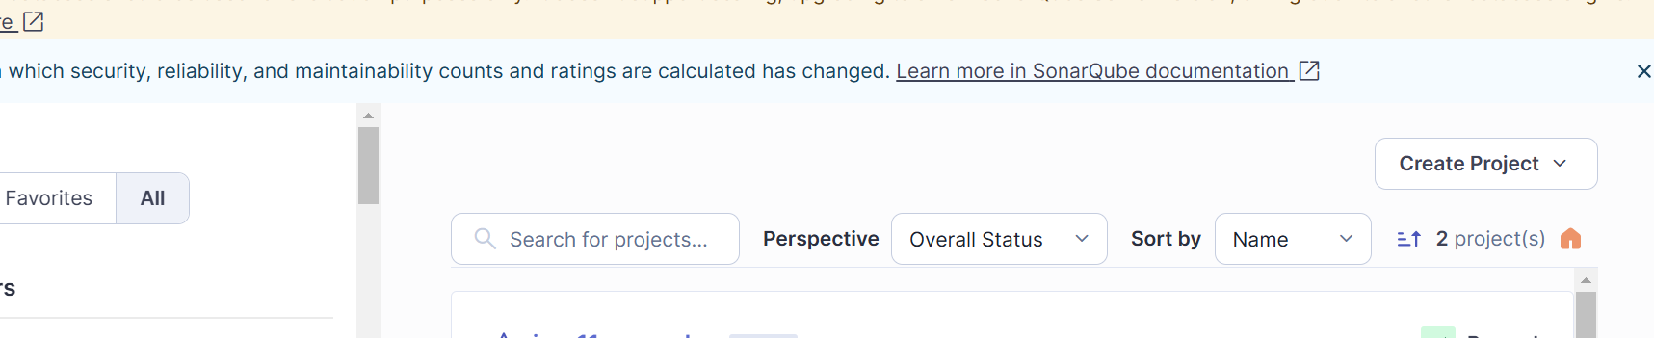

Create Token
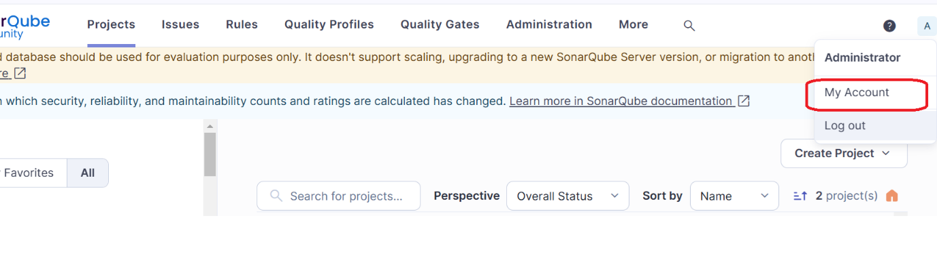
Based on the Jenkins pipeline from your document, here is the equivalent GitLab CI/CD pipeline in .gitlab-ci.yml format that performs the same stages and integrates with SonarQube for code quality analysis:
.gitlab-ci.yml
stages:
- checkout
- test
- report
- package
- sonar

variables:
SONARQUBE_URL: "http://192.168.111.130:9000" # Adjust this if needed
SONARQUBE_PROJECT_KEY: "myproject"
GIT_DEPTH: "0" # Required for SonarQube analysis
MAVEN_OPTS: "-Dmaven.repo.local=.m2/repository"

cache:
paths:
- .m2/repository

before_script:
- echo "Using Java version:"
- java -version
- echo "Using Maven version:"
- mvn -version
checkout:
stage: checkout
script:
- echo "Checkout is handled automatically by GitLab CI"
test:
stage: test
script:
- mvn clean
- mvn compile
- mvn test

generate-cucumber-report:
stage: report
script:
- mvn verify
create-package:
stage: package
script:
- mvn package
generate-report:
stage: report
script:
- mvn verify
sonarqube-analysis:
stage: sonar
script:
- mvn sonar:sonar \
-Dsonar.projectKey="$SONARQUBE_PROJECT_KEY" \
-Dsonar.host.url="$SONARQUBE_URL" \
-Dsonar.login="$SONAR_TOKEN"
only:
- master
GitLab CI/CD Secret Setup
- Go to GitLab > Project > Settings > CI/CD > Variables.
- Add a variable:
  - SONAR_TOKEN → set it to your actual SonarQube token.

